Lightspan OLT bootup document

Author | Alden Zhou/Derrick Song
Owner | Alden Zhou/Derrick Song
Organization | NOKIA Network Integration - Fixed Networks Division
Approver
Document ID
Document location
Document Change History
Version | Status |  | Date | Author |  | Description of changes
0.1 | Draft |  | 12-06-2025 | Alden Zhou/Derrick Song |  | Initial draft

Contents
1 Introduction 3
1.1 Preface 3
2 Preparation 3
2.1 Hardware preparation 3
2.2 Software preparation 6
3 OLT Upgrade 7
3.1 Upload the software 7
4 OAM IP configuration 9

1 Introduction

1.1 Preface
This document describes the process to boot up a new OLT. How to upgrade from factory software. How to config in/out bind OAM IP address.

2 Preparation

2.1 Hardware preparation
- Prepare a PC with Windows system
- Connect the PC and the LEMI port of OLT by cable

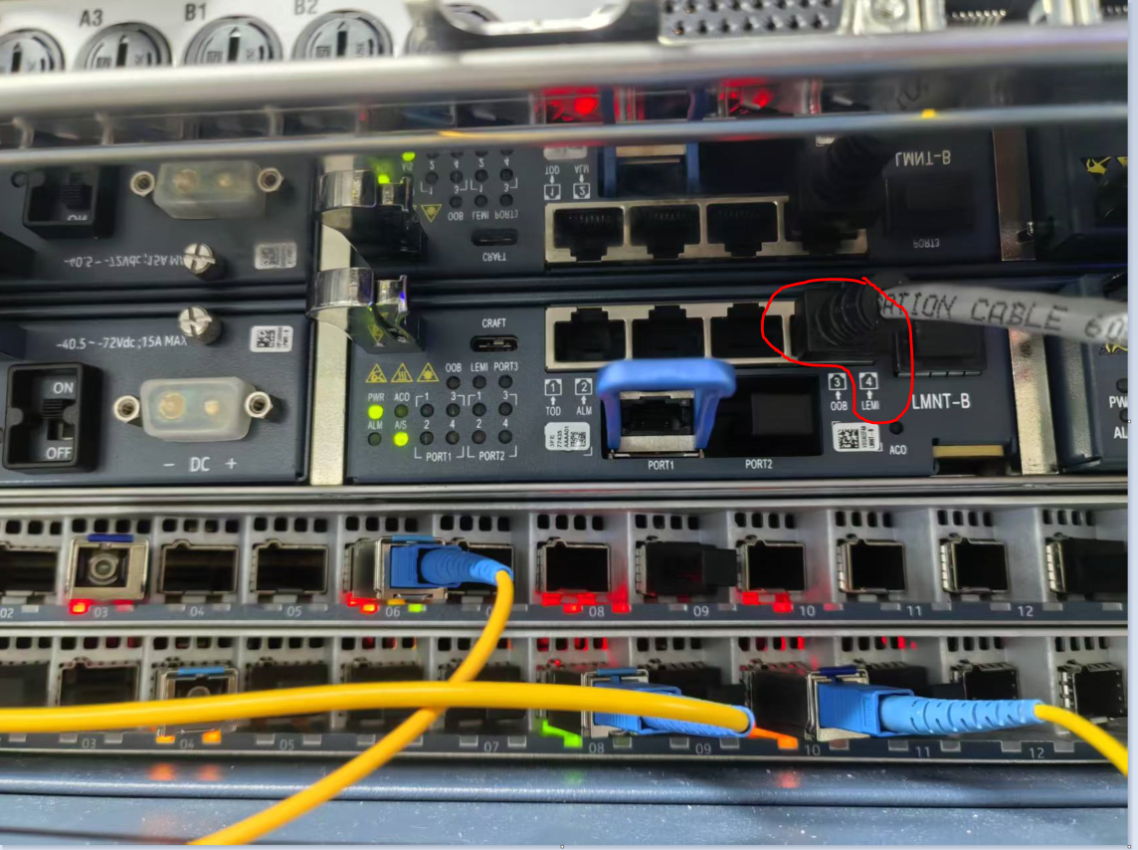
- Configure the IP address of the PC as dual IP address
Configure the first IP and click the Advanced button
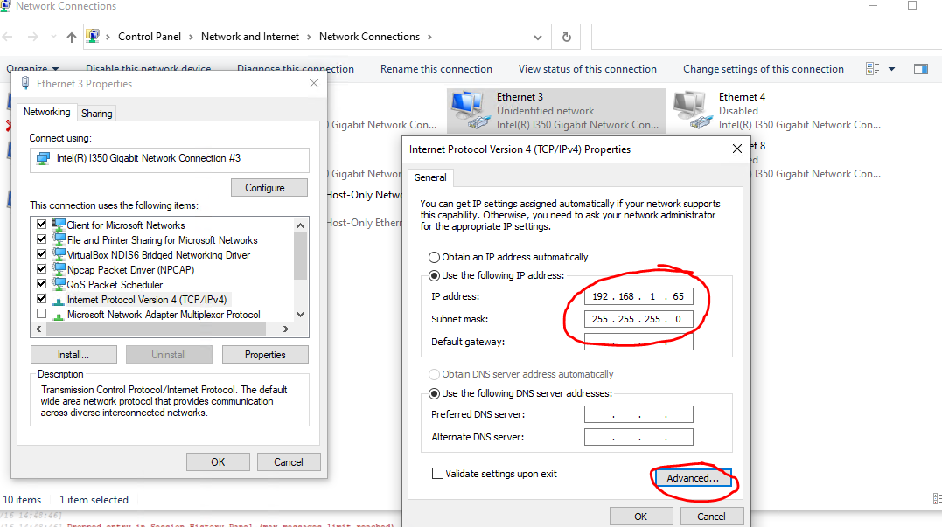
Add a new IP address with below information
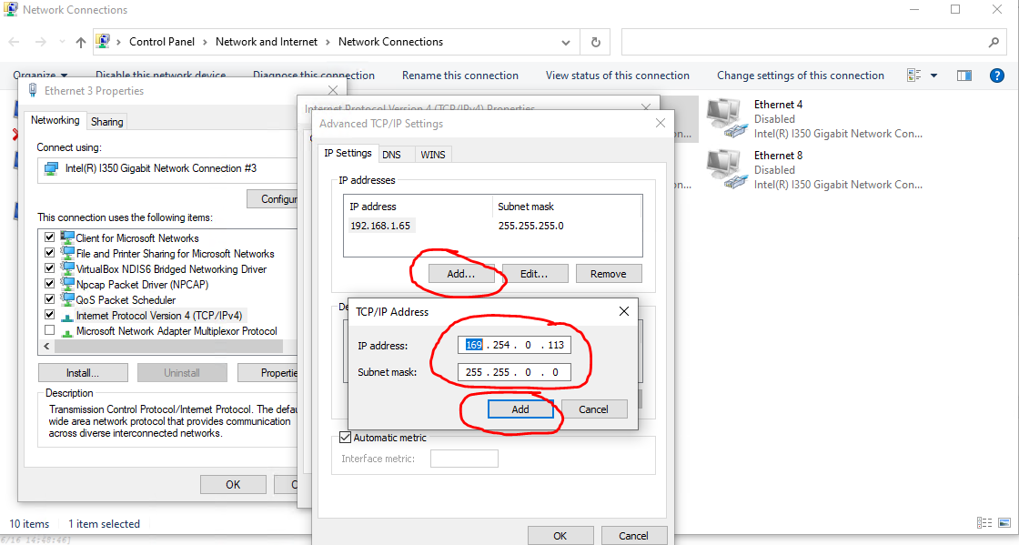

The result like this
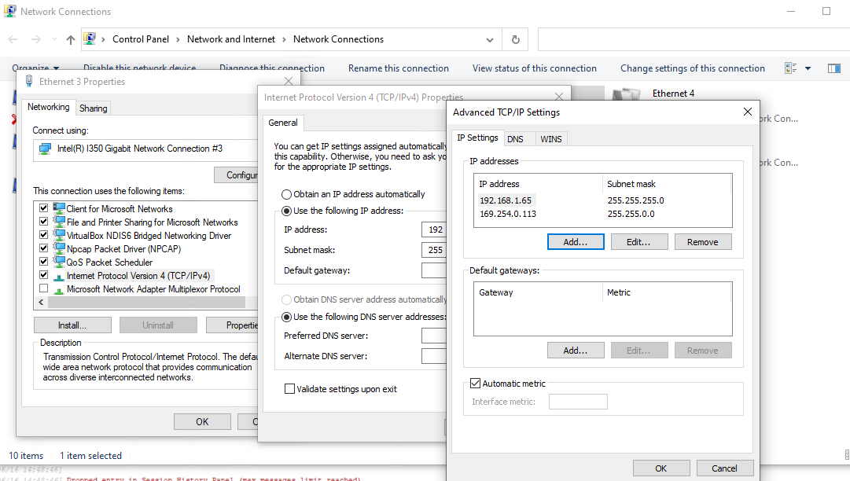
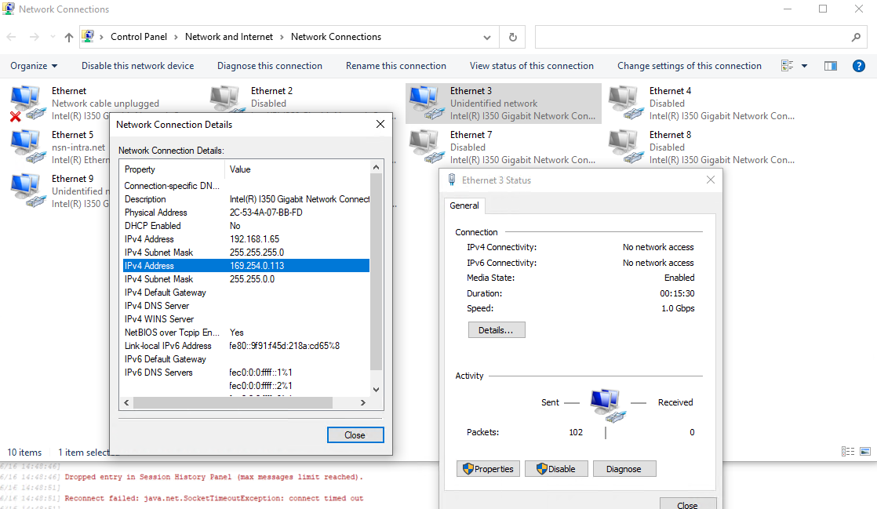

2.2 Software preparation
Prepare the Alto from below link
Alto-1.2.3-win.7z
Prepare the new OLT software
- Decompress the Alto in your Windows PC
- Decompress the OLT software into such folder
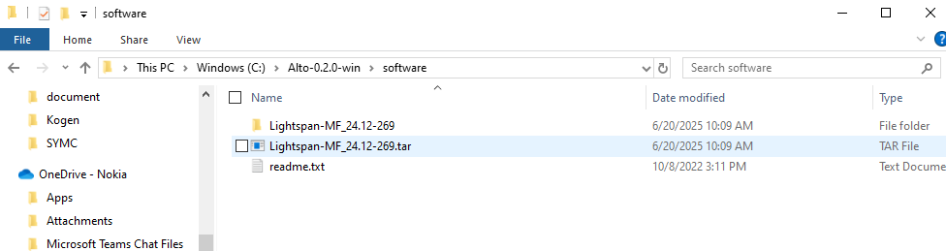
- Double click Alto.exe to run the application
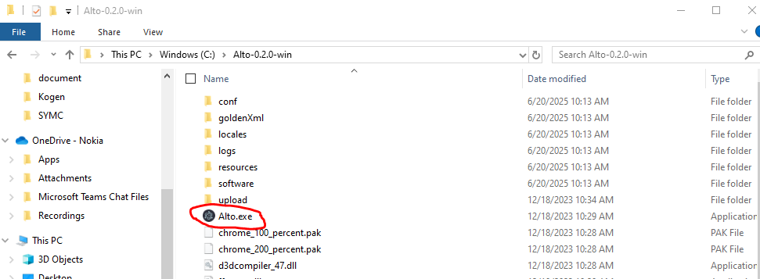

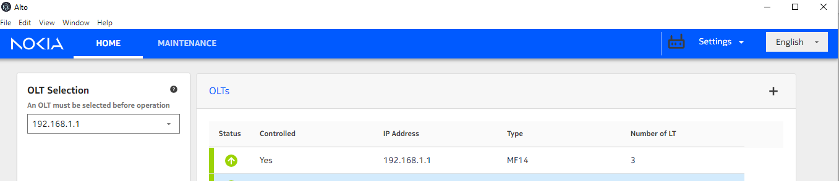

3 OLT Upgrade
Click Maintenance tab and go to Software Management menu. We recommend upgrading LTs first, and then upgrading NT

3.1 3.1 Migrate the configuration
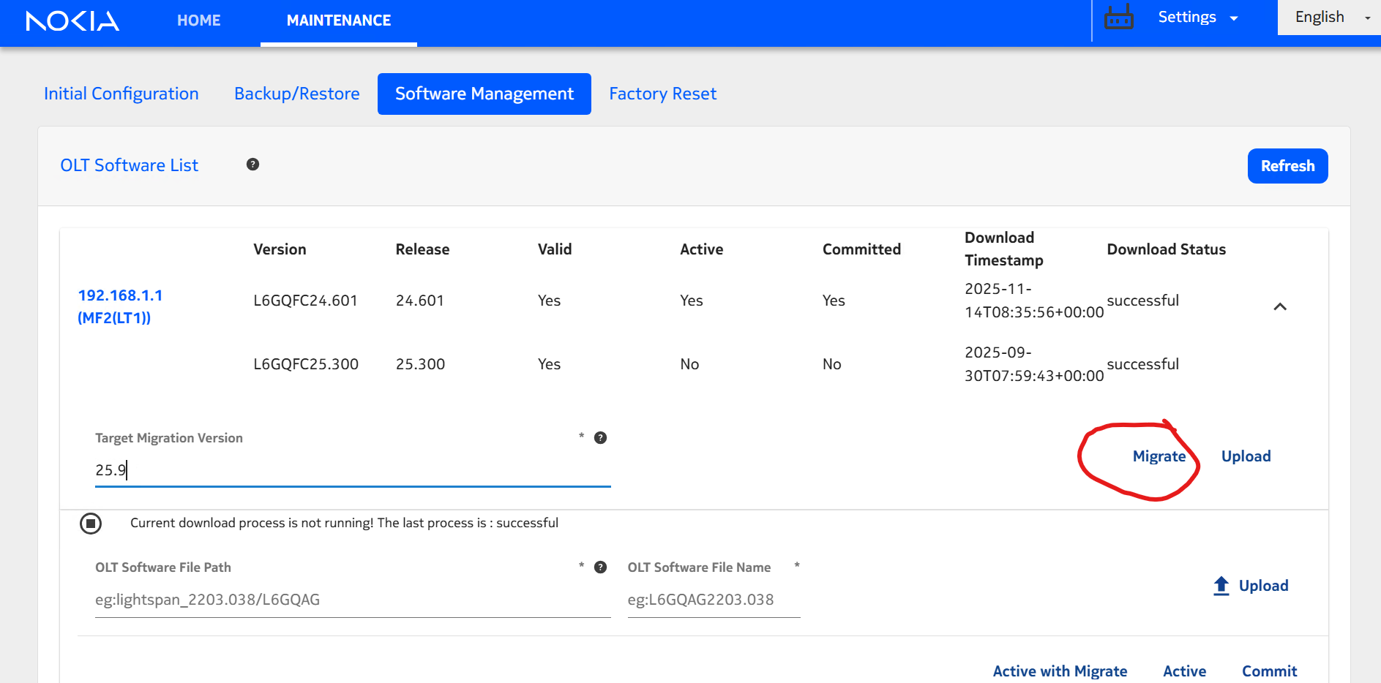
- Input the target migration version, such as 25.9
- Then click migrate. It will take several minutes. Then the migration file will be placed in software folder
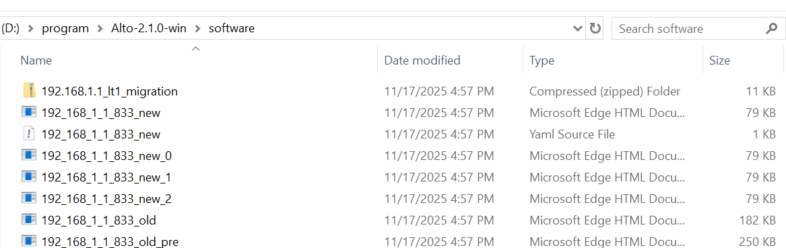
- Click upload button to upload the migration file into OLT
Currently, the support list is
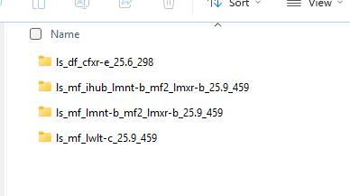

3.2 Upload the software
- Input the folder name and file name as what it is in Alto software folder
- Then click upload. It will take several minutes. You can click refresh button to check. When it is ready, the uploaded software should be: Valid : Yes, Active: No, Committed: No
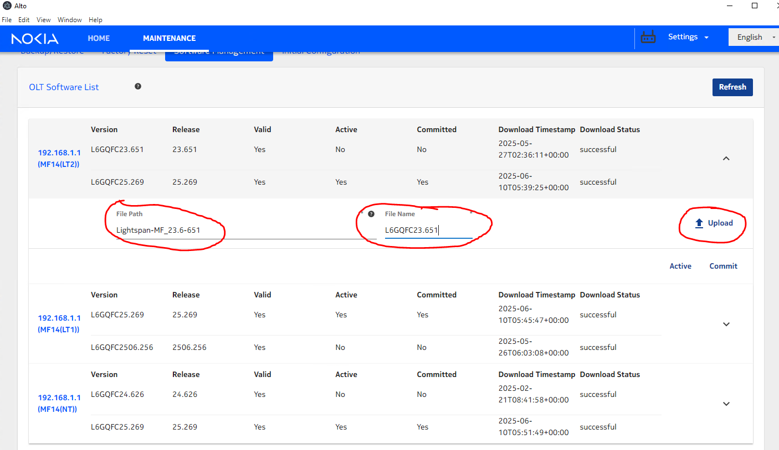
- Click Active button. The OLT will take several minutes to be active with CLEAN configuration. Click Active with Migrate button. The OLT will take several minutes to be active with MIGRATED configuration. You can click refresh button to check. When it is ready, the software should be: Valid : Yes, Active: Yes, Committed: No
- Then click the Commit button.
- When it is ready, the software should be: Valid : Yes, Active: Yes, Committed: Yes
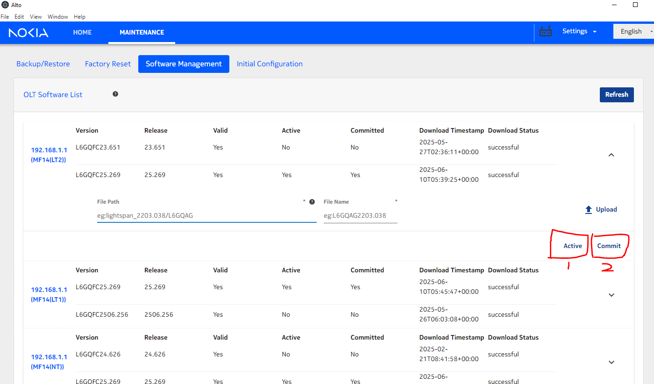

- Then follow the same procedure to upgrade the left LT cards. Then NT card

4 OAM IP configuration
- Prepare the xml files here
- Go to this menu
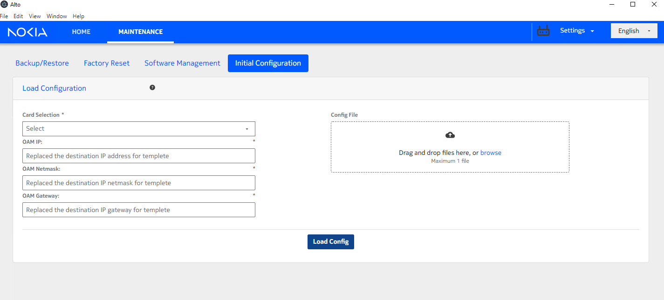
- If you want to use in band OAM IP, drop “ihubIp_inband.xml” in right and input your IP address in left. Select “Ihub” in card selection. Then click Load Config button.
- If you want to use out band OAM IP, please change to “ihubIp_outband.xml”
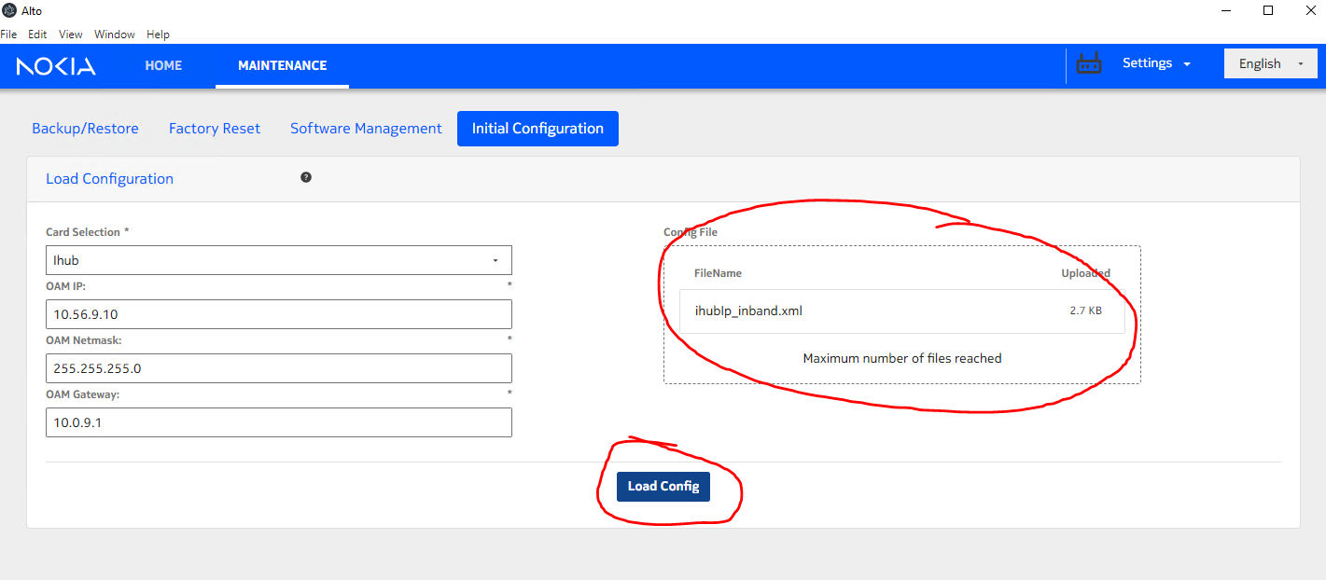
- Then drop the “commit.tpl” in the right, and click Load Config button.
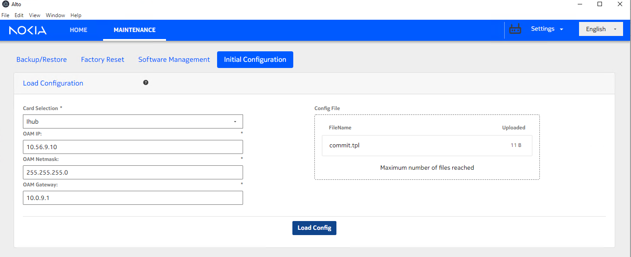

5 Q&A

5.1 LT card missed
Upgrade OLT from factory software to 24 or 23 software by Alto, LT cards can not be detected.
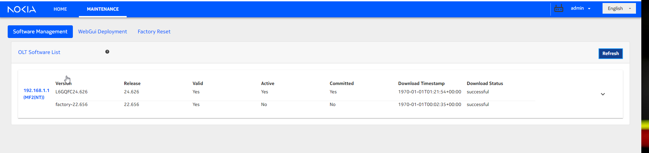
Solution:
Factory reset the NT card by Alto one or two times. Then unplug/plug the LT cards.
